Integrated Solution Design
Service Order Management for Utilities
SAP Service Cloud V2 · SAP S/4HANA Utilities · SAP Field Service Management · SAP Service and Asset Manager
By Jamparaju Nammi

Attribute | Value
Document | Integrated Solution Design – Service Order Management
Author | Jamparaju Nammi
Version | 1.0
Date | July 10, 2026
Status | Draft
Scope | R1 – Real-time appointment scheduling ·  R2 – Service order determination for Move-In/Move-Out/Transfer

Table of Contents
Table of Contents 2
1. Purpose and Scope 5
2. Requirements Summary 5
3. Solution Architecture Overview 6
6
3.1 Component Roles 6
3.2 Integration Landscape 7
3.3 Key Design Decisions 7
4. Use Case 1 – Service Order Creation from SC V2 Real-Time Appointment Scheduling 8
4.1 Principles 8
4.2 Process Flow 9
9
4.3 FSM Booking API Usage 10
4.4 Slot-to-Order Data Mapping 10
4.5 UI Behavior in SC V2 10
4.6 Error Handling and Fallback 13
5. Use Case 2 – Move-In / Move-Out / Transfer with Automatic Service Order Determination Service Order Determination Real time scheduling 14
5.1 Overview Service Order Determination 14
5.2 Process Flow 14
5.3 Rule Inputs 15
5.4 Determination Sequence 16
5.5 Decision Matrix – Move-In (per installation) 17
5.8 Decision Matrix – Move-Out (per installation) 17
5.7 Transfer 18
5.8 Service Contract – Z_UTIL_SO_PROPOSAL (S/4HANA OData) 18
5.9 Legacy (CRM and ECC) → Target SC V2+SAP S/4 HANA, FSM Mapping 18
5.10 UI Behavior in SC V2 18
5.11 Service Order Determination BRF+ Technical Design 22
Functions and Result Structure 22
Key Condition Derivations 22
Decision Table DT_MOVE_IN (online) 22
Decision Table DT_MOVE_OUT (online) 23
Daily Batch Tables (RSS reconnect/disconnect) 23
Service Order Codes 24
6. End-to-End Scenarios 25
6.1 Move-In requiring Turn-On (field) 25
6.2 Move-Out with Remote Disconnect (AMI) 25
6.3 Transfer 25
6.4 Standalone Service Order 25
7. Object and Status Mapping 25
7.1 Object Mapping 26
7.2 Status Mapping 26
8. Interface Inventory 26
9. Non-Functional Design 27
9.1 Security 27
9.2 Performance Targets 27
9.3 Resilience and Operations 27
10. Assumptions and Open Points 28
10.1 Assumptions 28
10.2 Open Points 28
11. Glossary 28

1. Purpose and Scope
This document defines the target architecture and integrated solution design for Service Order Management across SAP Service Cloud Version 2 (SC V2), SAP S/4HANA Utilities, SAP Field Service Management (FSM), and SAP Service and Asset Manager (SSAM). It addresses two core business Use cases, along with the standalone Service Order Management process that supports both scenarios:
- Use Case 1 – Service Order Creation from SC V2
A Customer Service Representative (CSR) initiates a service order in SAP Service Cloud Version 2 (SC V2). During the order creation process, the solution retrieves available appointment slots from SAP Field Service Management (FSM) in real time. The CSR selects the preferred appointment slot and confirms the request. The service order is then created in SAP S/4HANA Utilities and subsequently scheduled and dispatched through SAP FSM for field execution.

- Use Case 2 – Move-In / Move-Out / Transfer
During the processing of a Move-In, Move-Out, or Transfer, the solution automatically determines whether the required activity should be fulfilled through a field service order or a remote command using Advanced Metering Infrastructure (AMI) / Remote Service System (RSS).
Based on the business and device conditions, the system proposes the appropriate service order type, such as Meter Exchange, Meter Read, Service Turn-On, Service Turn-Off, or Meter Removal. When a field service visit is required, the solution retrieves available appointment slots from SAP FSM in real time. The CSR selects the preferred appointment slot and confirms the request. The corresponding service order is then created in SAP S/4HANA Utilities and scheduled in SAP FSM for field execution.
Where the activity can be completed remotely through AMI/RSS, the appropriate remote command is initiated, eliminating the need for a field service visit.

SC V2 remains the customer-engagement layer, S/4HANA Utilities the system of record and rules engine, FSM the real-time scheduling and dispatch engine, and SSAM the mobile execution client for internal field technicians.

2. Requirements Summary
# | Requirement | Where it surfaces | Outcome
R1 | The CSR creates a service order, and the system retrieves real-time appointment availability from FSM. The CSR reviews the available time slots with the customer, selects the preferred slot, and confirms the appointment. | Standalone Create Service Order screen. | CSR books a firm appointment on the first contact; FSM is the single scheduling source of truth.
R2 | System determines whether a service order is required and proposes the order type from meter status, installation status, disconnection status and meter type, and retrieves live appointment slots from FSM; CSR selects and confirms with customer. | SC V2 Move-In/Move-Out/Transfer wizard – Service step, evaluated per service line/installation. | Only genuinely required orders are created; obsolete open orders are surfaced for cancellation; unnecessary truck rolls are avoided.

3. Solution Architecture Overview

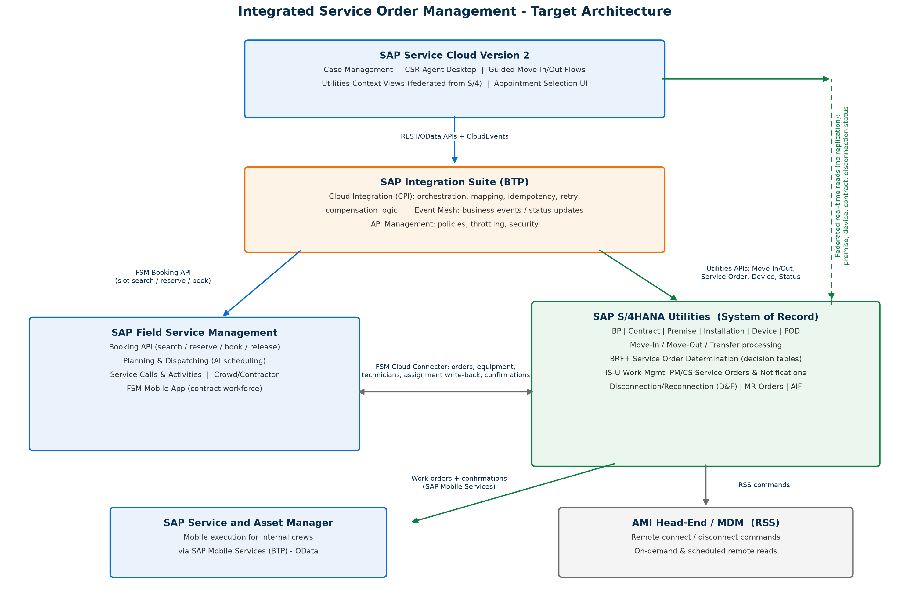

Figure 1 — Target architecture, integration landscape and the prepackaged iFlow packages / custom services on each connection

3.1 Component Roles
Component | Role in the solution
SAP Service Cloud V2 (Utilities extension) | Customer engagement layer. CSR runs Move-In/Move-Out/Transfer guided flows and creates cases and service orders. Hosts the appointment-slot UI and the service order proposal panel in the Service step. Never the system of record for utility master data.
SAP S/4HANA Utilities | System of record: business partner, contract account, utility contract, premise, point of delivery, installation, Meters, move-in/move-out documents, billing. Owns the Service Order Eligibility & Proposal rules (BRFplus decision tables) and creates the executable IS-U/Service work orders. Triggers remote AMI commands where applicable.
SAP Field Service Management (FSM) | Scheduling engine and dispatch. The Booking API answers real-time slot searches from SC V2 using scheduling policies (skills, service areas, capacity, travel). Dispatch board for planners; FSM mobile for third-party/contractor crews.
SAP Service and Asset Manager (SSAM) | Mobile execution for internal field technicians against S/4HANA work orders (online/offline), including the Meter Management scenario for device installation, removal, replacement and meter readings. Completion data flows back to S/4HANA.
SAP BTP / Integration Suite | Integration layer: prepackaged iFlows for SC V2 – S/4HANA Utilities and S/4HANA – FSM, Event Mesh for status events, destinations and connectivity (Cloud Connector), and the custom side-by-side services for the FSM Booking API and Z_UTIL_SO_PROPOSAL.

3.2 Integration Landscape
Runtime connections used by this design, mapped to the prepackaged SAP iFlow packages that implement each hop wherever standard content exists (see Section 8 for the full interface inventory):
From → To | Purpose | Technology / Package
SC V2 → FSM | Real-time slot search and booking (R1) | FSM Booking API (REST, OAuth2) via a custom BTP side-by-side service
SC V2 → S/4HANA Utilities | Eligibility & proposal call (R2); federated Customer 360, premise & service status; move-in/move-out posting | Custom Z_UTIL_SO_PROPOSAL OData action; SC V2 for Utilities Premise Integration with S/4HANA (prepackaged iFlows)
SC V2 ↔ S/4HANA Service | Service order replication and status sync | Prepackaged SC V2 – S/4HANA service transaction integration (Integration Suite / Event Mesh)
S/4HANA ↔ FSM | Work order → FSM service call & activity; assignment, time, materials back | SAP S/4HANA Integration with SAP Field Service Management (prepackaged iFlow package)
S/4HANA ↔ SSAM | Mobile work order execution for internal crews, incl. device install/removal and meter reads | SAP Mobile Services + SSAM mobile add-on (Meter Management)
S/4HANA → AMI head-end / MDM | Remote disconnect/reconnect/on-demand read for remotely switchable meters | Existing AMI integration (out of scope; consumed as a service)

3.3 Key Design Decisions
# | Decision | Recommendation and rationale
D1 | Which system is the scheduling engine for CSR-facing slot search? | FSM Booking API. It is the only component with real capacity, skills, service-area and travel-time awareness.
D2 | Where do executable work orders live? | S/4HANA. SC V2 service orders replicate to S/4HANA Service/IS-U orders (system of record for regulatory, device and billing linkage), which flow to FSM for dispatch and to SSAM for internal-crew execution — one order backbone for both mobile channels.
D3 | Where does the eligibility/order-type determination logic live? | S/4HANA, as BRFplus decision tables exposed through one custom OData service (Z_UTIL_SO_PROPOSAL). All meter, installation and disconnection data lives there, so rules run next to the data, stay business-maintainable, and are reusable by other channels (self-service portal, IVR).
D4 | Which mobile client executes which order? | SSAM for internal technicians (meter set/exchange, turn-on/off with device operations posted to IS-U); FSM mobile for contractor/crowd workforce. Routing by work center / responsible unit on the order.
D5 | Remote-capable (AMI) meters | If the device supports remote disconnect/reconnect/read, no field appointment is offered; S/4HANA triggers the AMI command and the SC V2 Service step shows 'remote execution – no appointment required'.
D6 | Slot integrity between search and submit | FSM booking reservation: the selected slot is held (configurable TTL, default 10 minutes) when the CSR picks it, and confirmed on order submit. If the hold expires or the slot is taken, the UI forces a re-search (HTTP 409 handling).

4. Use Case 1 – Service Order Creation from SC V2 Real-Time Appointment Scheduling

4.1 Principles
- One scheduling truth: every CSR-visible slot comes from the FSM Booking API; no local calendars in SC V2 or S/4HANA.
- Appointment offered only when needed: the Service step asks for slots only for proposals with execution mode FIELD (Section 5). Remote (AMI) and no-order outcomes never show a slot picker.
- Book on the first call: slot search, customer confirmation and reservation happen inside the guided flow; booking is finalized when the CSR submits the Move-In/Move-Out or saves the service order.
- 4-hour appointment windows (08–12, 12–16, 16–20, 20–24) and capacity allocations are reproduced as FSM booking time-slot profiles and scheduling-policy capacity. 'Meet Me' phone, 'adult must be present' and 'confirmed with caller' indicators become fields on the SC V2 appointment panel mapped to FSM activity/service-call fields.

4.2 Process Flow

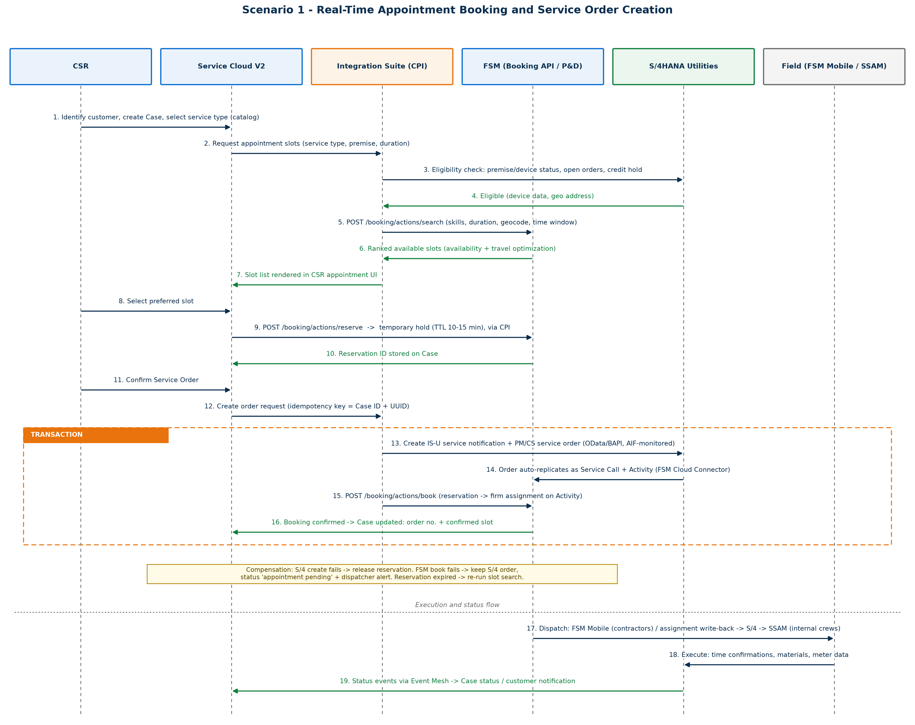

Figure 2 — Sequence: slot search, reservation, order creation and booking confirmation
- CSR Opens the SO creation work center to create the SO after discussion with customer
- CSR reaches the Service step (Move-In/Move-Out wizard) or opens Create Service Order. The eligibility response (Section 5) or the chosen service order type marks the work as FIELD execution with a duration and required skill.
- SC V2 calls the slot search with premise/service address (geo-coded), earliest start, search horizon (e.g. 10 business days), duration, required skills, and the booking time-slot profile (4-hour windows).
- FSM Booking API evaluates scheduling policy (technician skills, service areas, working time, existing bookings, travel) and returns ranked available slots.
- SC V2 renders the slots grouped by day and window — the functional successor of the legacy 'Specific Appointment Range' grid, including a remaining-capacity indicator.
- CSR agrees a slot with the customer and selects it; SC V2 sends a reservation request, FSM holds the slot (TTL, default 10 min) and returns a booking ID.
- CSR completes the flow. On submit: the SC V2 service order stores Requested Start/End = slot start/end plus the FSM booking ID; the order replicates to S/4HANA; the S/4→FSM connector links the executable order to the confirmed booking.
- Dispatcher sees the activity already pinned to the booked window; releases/assigns per policy. Technician receives it in SSAM (internal) or FSM mobile (contractor).
- Completion (time, materials, meter data, device install/removal) posts to S/4HANA; status events update the SC V2 order and case timeline; the customer can be notified.

4.3 FSM Booking API Usage
Call | Purpose | Key payload elements
POST .../booking/v1/actions/search-slots | Return available, ranked slots | duration ← SO type default; requiredSkills ← SO type mapping; address/geo ← premise; earliestStart ← requested date; timeSlotProfile ← 4-hour windows
POST .../booking/v1/actions/reserve | Hold the CSR-selected slot | slotId; TTL configurable (default 10 min); returns bookingId
POST .../booking/v1/actions/book | Confirm reservation at submit | bookingId; creates the planned assignment window in FSM
POST .../booking/v1/actions/cancel | Release on cancel / TTL expiry | bookingId; cancellation reason (parity with legacy 'Cancellation due to New Contract Creation')
Exact endpoint versions depend on the FSM tenant release; the integration is wrapped in one reusable BTP side-by-side microservice so the SC V2 UI is insulated from FSM API changes.

4.4 Slot-to-Order Data Mapping
FSM Booking response | SC V2 Service Order | S/4HANA order | FSM activity
slot.start / slot.end | Requested Start/End Date-Time (fields on the standalone Create Service Order screen) | Operation earliest start/latest finish; customer appointment window | Planned start/end; fixed booking (locked on dispatch board)
bookingId | Custom field: FSM Booking ID | Custom reference (order header text / extension field) | Native booking reference
technician (if exposed) | Not shown to CSR (window-level only) | — | Planned resource; dispatcher may re-optimize within window

4.5 UI Behavior in SC V2
- Standalone Create Service Order: after Service Order Type is chosen, a 'Find Appointment' action replaces manual entry of Request Start/End Date; selecting a slot fills both fields and stores the booking ID.
- Alerts area of the wizard shows determination warnings e.g. 'installation never set
- If the CSR proceeds without a slot, the order is created without a booking and flagged 'Scheduling pending – dispatcher to contact customer'; FSM auto-scheduling plans it within the horizon.
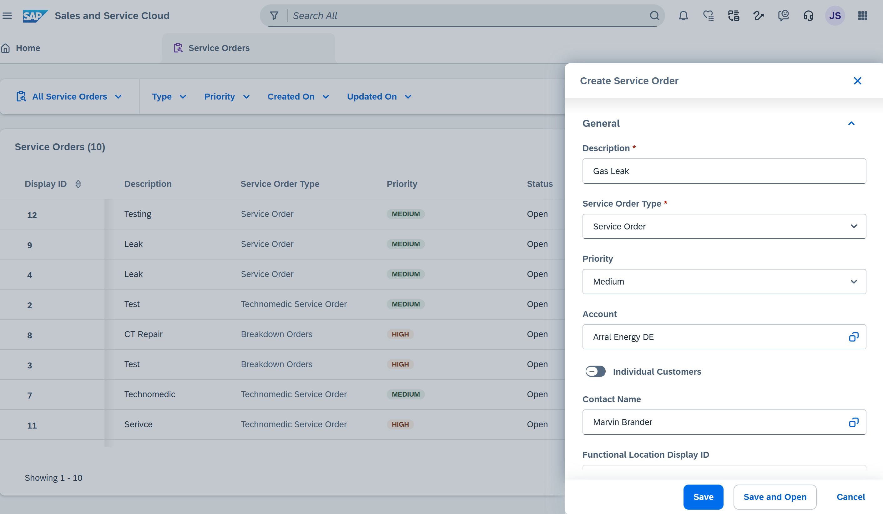
Figure 3a — SC V2 reference screen: Service Orders list and Create Service Order panel
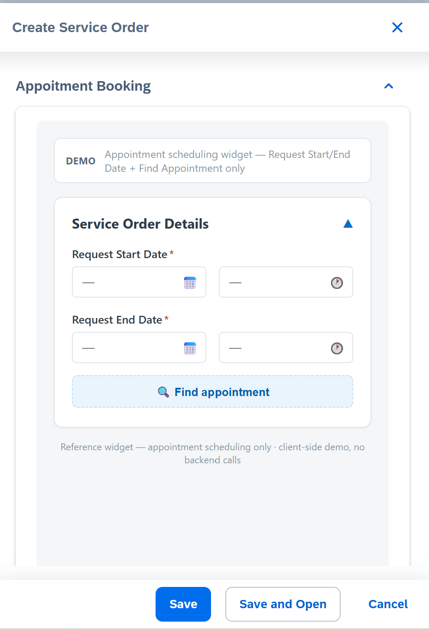
Figure 3b — SC V2 reference screen: standalone Create Service Order with Find Appointment
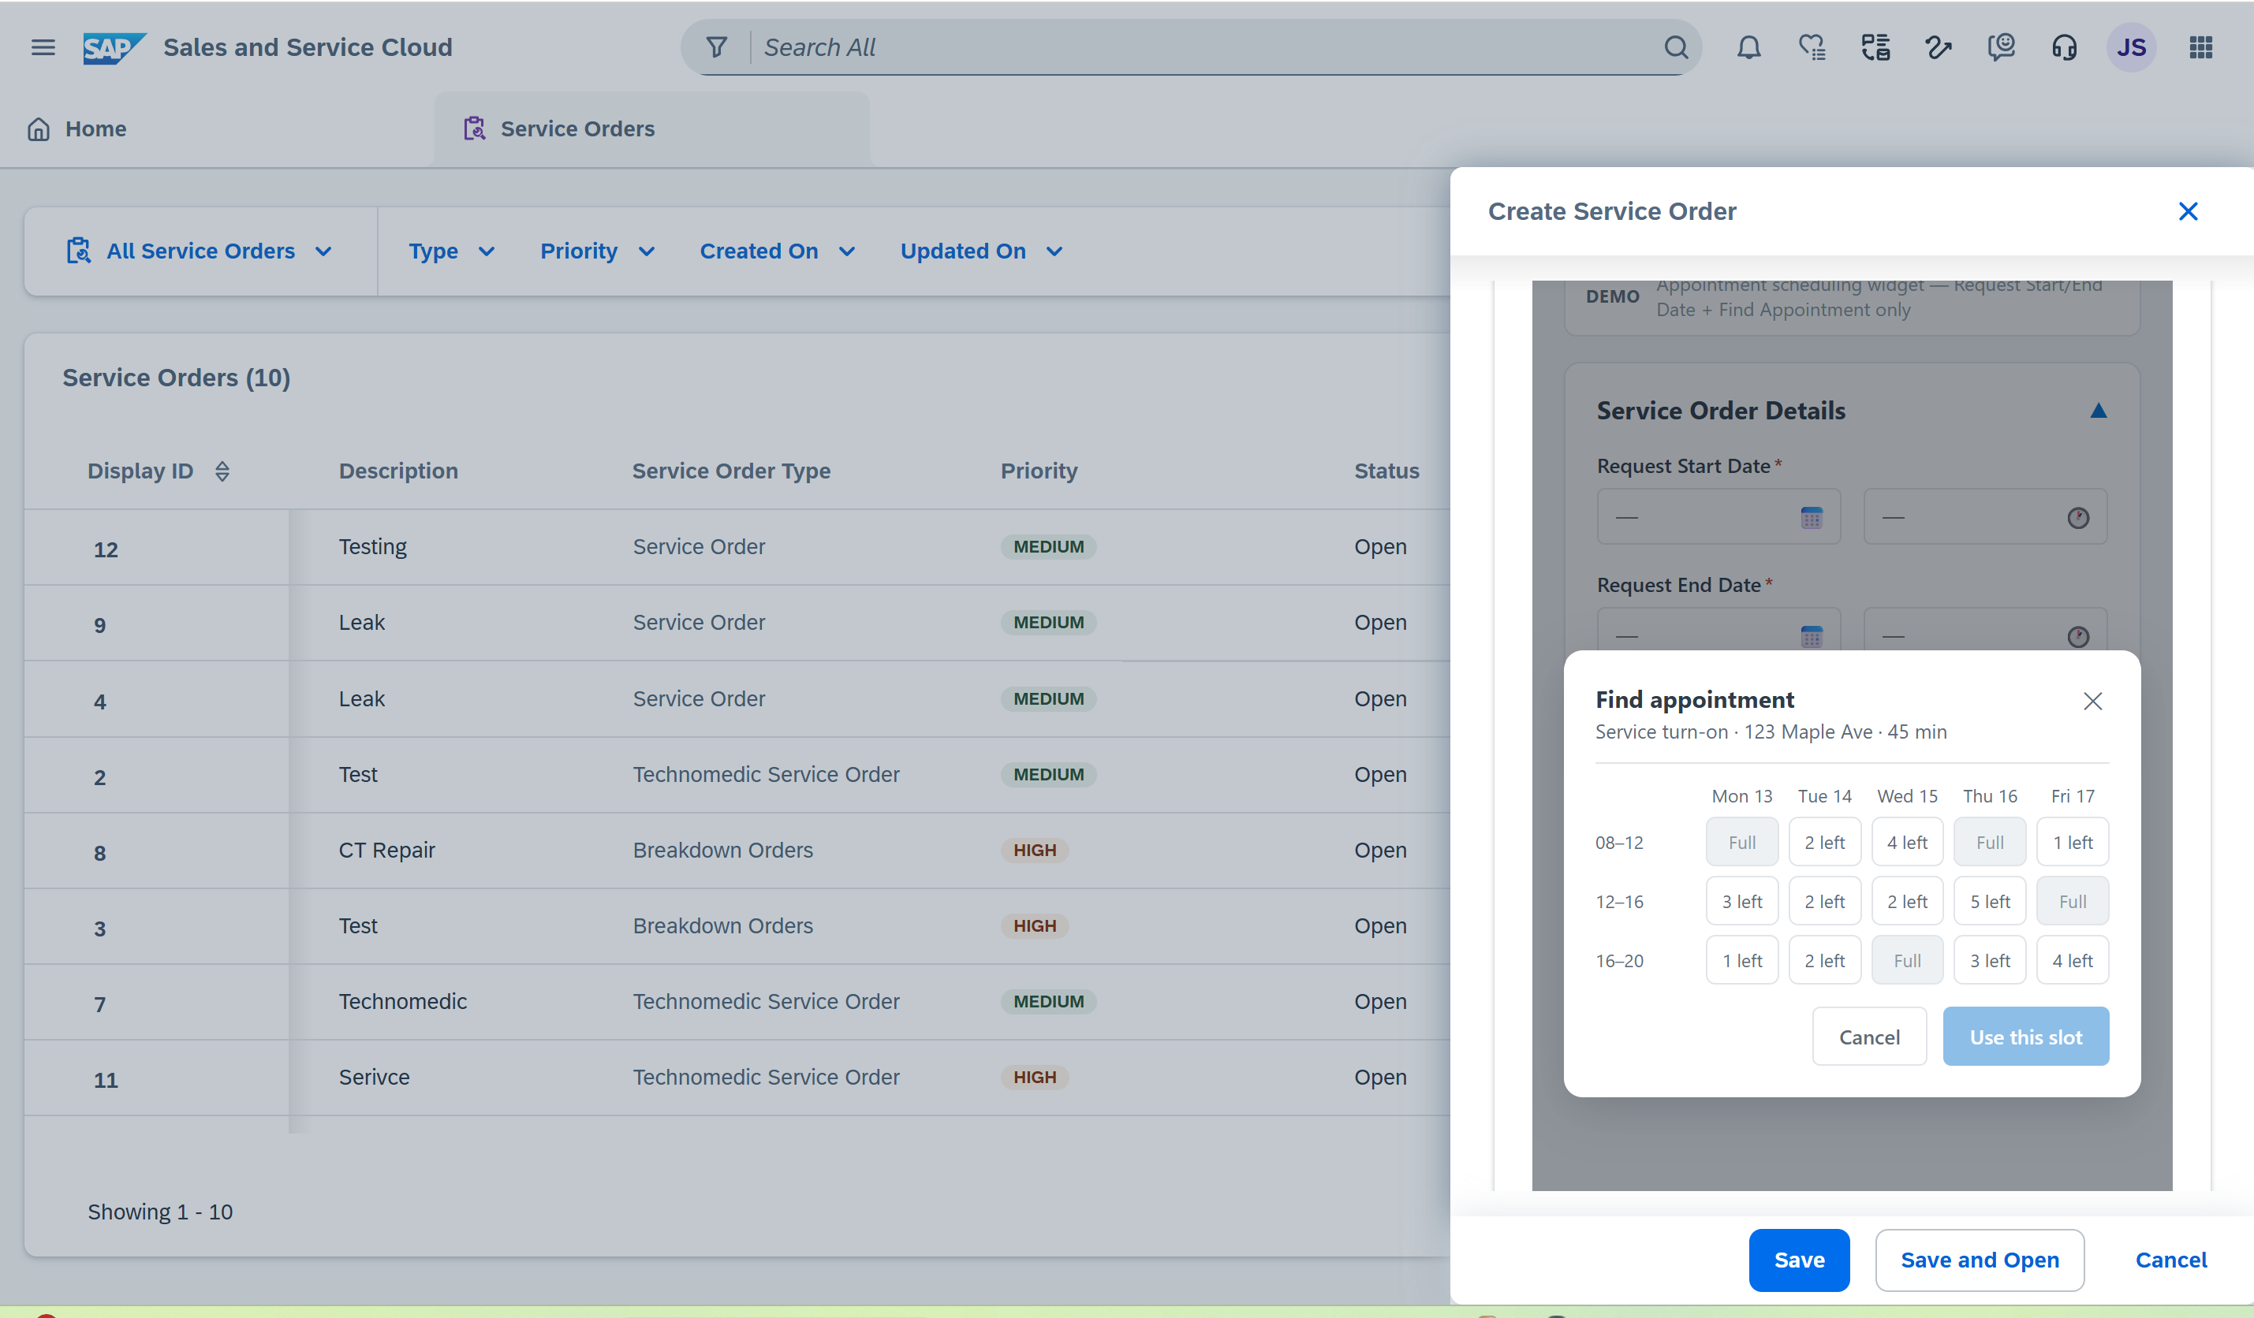
Figure 3c — SC V2 reference screen: Find Appointment slot grid opened from Create Service Order
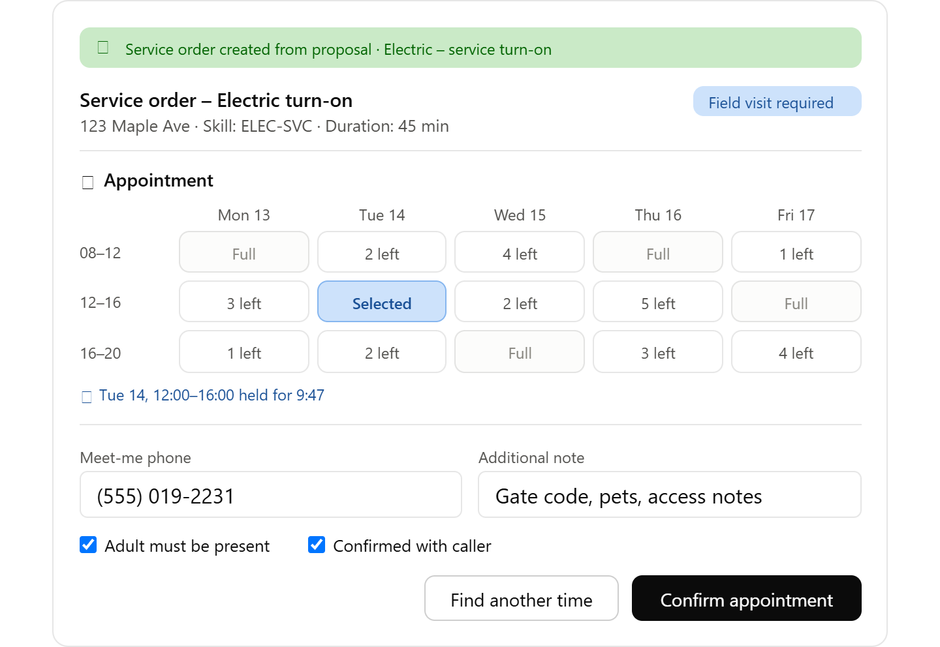

Figure 3d — SC V2 reference screen: slot selected and held, ready to confirm
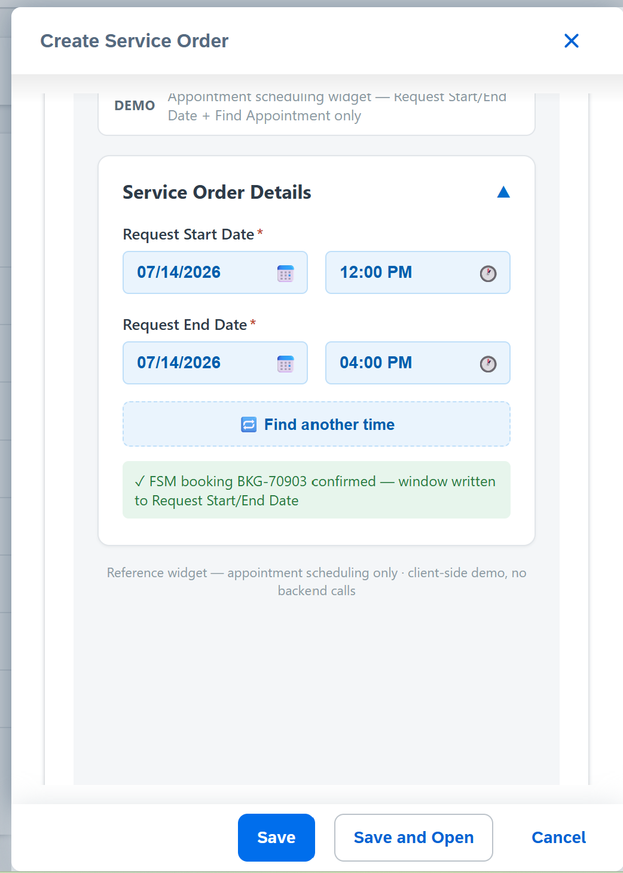
Figure 3e — SC V2 reference screen: booking confirmed, Request Start/End Date populated

4.6 Error Handling and Fallback
Scenario | System behavior
FSM unreachable / timeout (> 5s) | Slot panel degrades to 'Appointment cannot be offered right now'; CSR completes the flow; order is queued and FSM books asynchronously; customer is called back with the confirmed window.
Selected slot taken before confirm (409) | UI shows 'slot no longer available', auto-refreshes the search; CSR picks again.
Reservation TTL expired at submit | Submit re-attempts booking for the same window; if unavailable, wizard returns to the Service step with the refreshed grid.
Booking confirmed but order replication fails | Integration Suite retries with exponential backoff; monitoring alert; booking is auto-cancelled if the order cannot be created within the retry window.
Order cancelled after booking | Order cancellation event triggers Booking cancel (de-appointment) and a case timeline entry.

5. Use Case 2 – Move-In / Move-Out / Transfer with Automatic Service Order Determination Service Order Determination Real time scheduling

5.1 Overview Service Order Determination
The Service Order Determination engine is designed to ensure that service orders are created only when genuinely required, obsolete or no-longer-applicable orders are cancelled, and unnecessary field visits are avoided.
The determination logic is implemented using BRFplus decision tables within SAP S/4HANA Utilities. The decision service is exposed to SAP Service Cloud Version 2 (SC V2) through a synchronous OData service, enabling real-time determination during customer service interactions. The resulting service-order decisions are presented within the Service step of the guided flows, allowing agents to take the appropriate action based on the current customer, premise, installation, and device context.
Legacy hard-coded validations that previously relied on custom attributes and tables, such as ZINSTLN, ZDEVICE, and ZPREMISE, are replaced by configurable BRFplus business rules. The required rule inputs are derived from standard SAP IS-U master and transactional data, including relevant installation, device, premise, and service-related information.
This approach centralizes the service order determination logic within SAP S/4HANA Utilities, improves rule transparency and maintainability, reduces dependency on custom code, and provides SC V2 with a consistent, real-time decision mechanism for determining whether a service order should be created, retained, cancelled, or avoided.

5.2 Process Flow
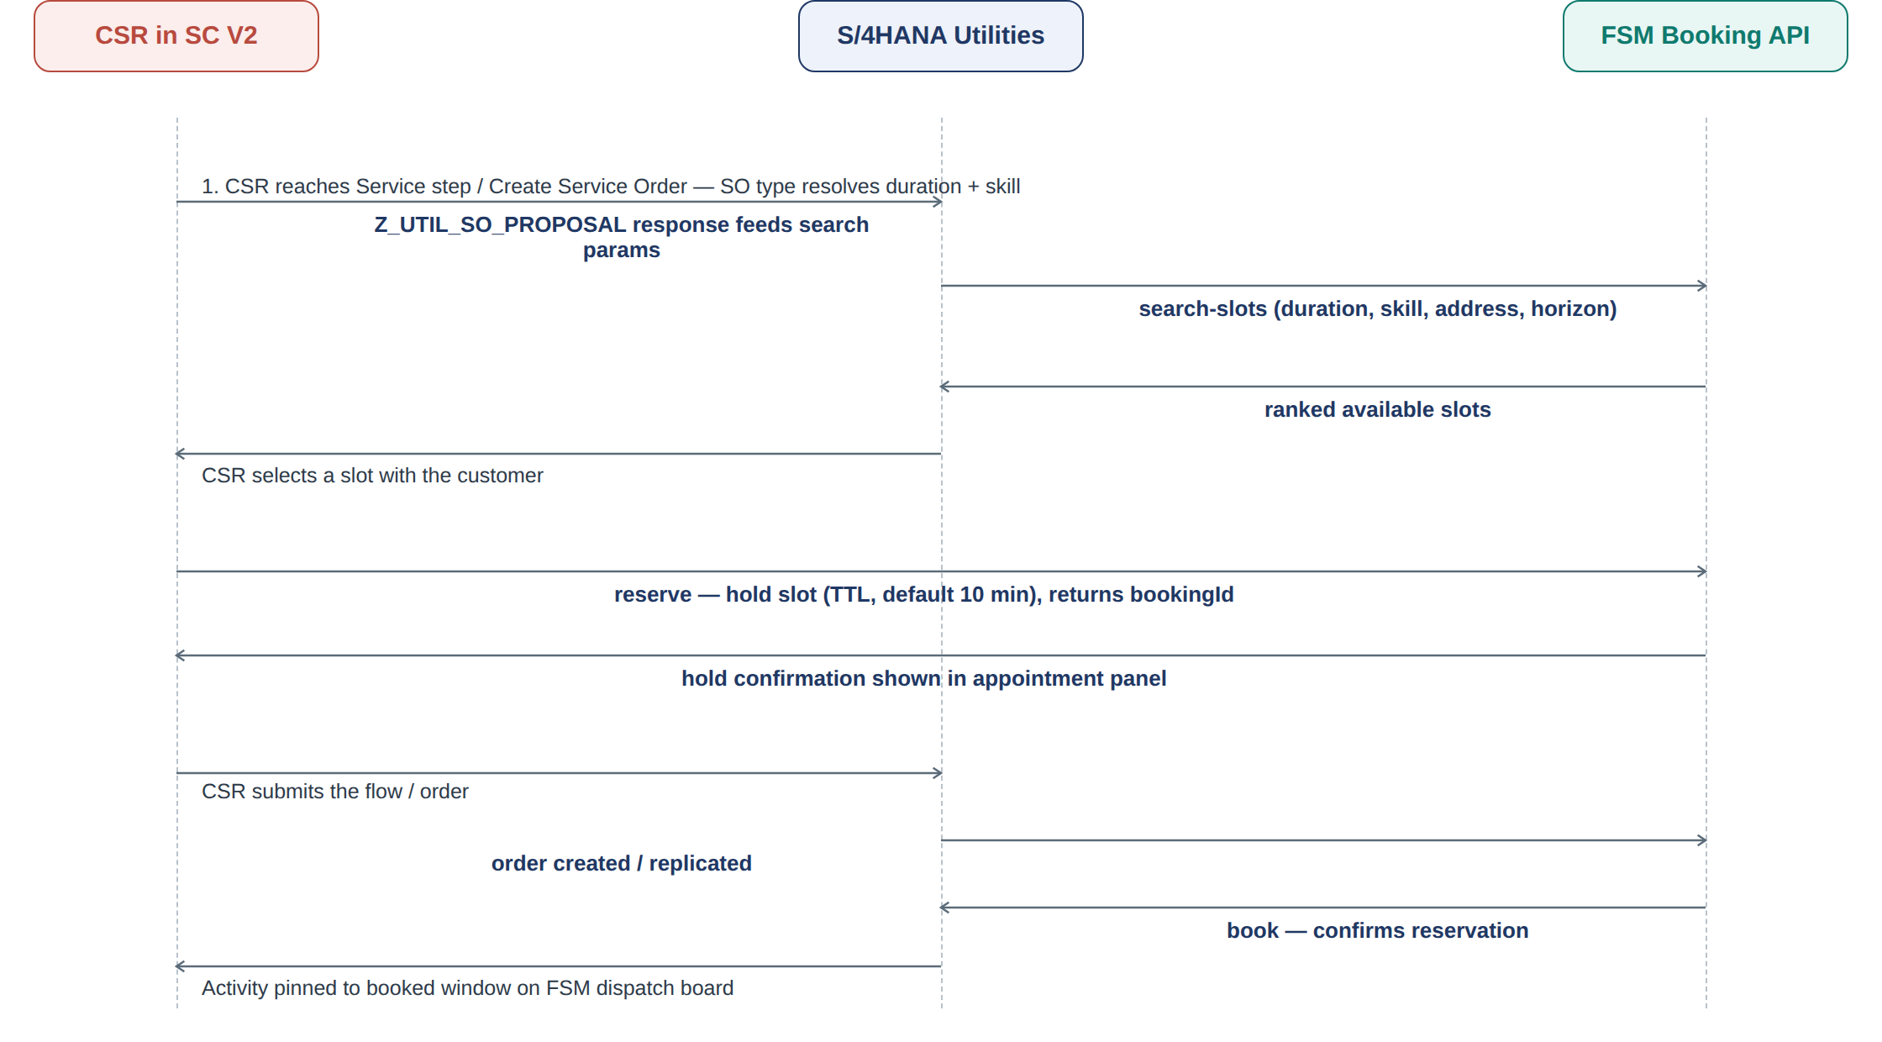

5.3 Rule Inputs
Input | Source in S/4HANA Utilities | Legacy CM_ENH_350 equivalent
Device installed at installation? | Device allocation (EASTS/EGERH) | ZINSTLN.zCurrentDevices
Unmetered installation flag | Installation facts/classification | ZINSTLN.UnMeteredIndicator
Installation ever metered | Device history at device location | ZINSTLN.ZGETLASTMETERCHARS
Disconnection status | Disconnection document (EDISCDOC/EDISCOBJ): 00/01/10 | ZINSTLN.DisconnectionStatusNew
Disconnect due to dunning? | Disconnect process variant DUNN + reference BP | ISU_DB_V_EDISCOBJ_SELECT_ANL
Meter read history / CSR-entered read | Meter reading results; wizard Validate/Estimate/Override | ZINSTLN.NOREADHIST
Rate/product requires demand read | Rate category / operand | Product Meter Type = MTD
Meter type & remote capability | Device category: AMI w/ switch, AMR, manual | (new — enables remote execution)
Meter certification / sampling status | Device certification data | (new — drives Meter Exchange)
Division / service type | Utility installation division | Division 01/02 logic
Open orders/notifications at device location | Open IS-U orders, planned start within past year | VIQMEL selection
Credit/ID gating | SC V2 flow context flags | FACTA / Positive ID / Security Deposit rule

5.4 Determination Sequence
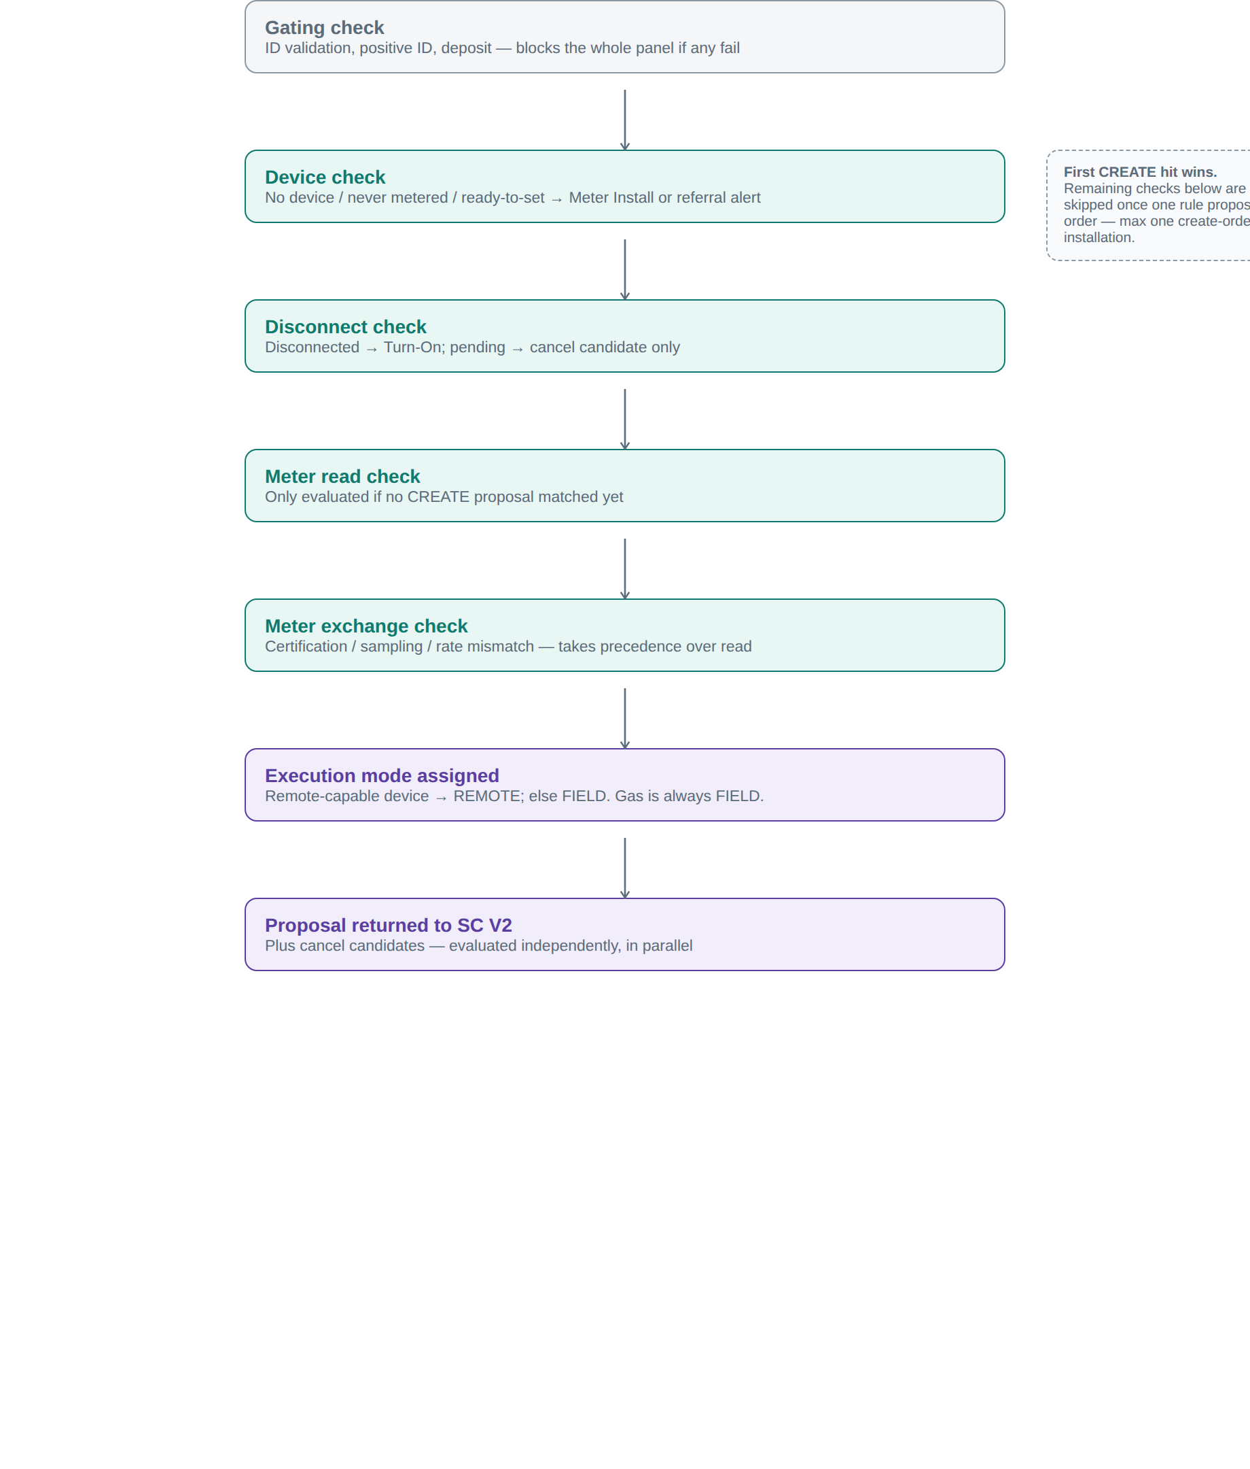
Figure 4 — Eligibility rule chain: gating first, first CREATE hit wins, cancellation runs independently
Executed per installation/service line (first CREATE hit wins — max one create-order per installation):
- Gating: ID validation failed / positive ID pending / deposit unpaid → order panel disabled (legacy 'disable Notification view' rule).
- Device check: no device, never metered → no order + referral alert unless ready-to-set → Meter Install. No device, previously metered → Meter Reinstall (gas: meter-size validation).
- Disconnect check: disconnected → Turn-On (dunning-related → credit-check subflow first); pending → cancel candidate only.
- Meter read check (only if no create-order yet): no usable history or demand rate → Move-In Meter Read.
- Meter exchange check: certification expired / sampling due / incompatible device → Meter Exchange (precedence over Read).
- Execution mode: remote-capable device → REMOTE; otherwise FIELD. Gas turn-on/turn-off is always FIELD (safety).
- Cancellation determination: open orders/notifications at the device location, planned start within the last year, listed as CANCEL candidates (legacy Cancel table / VIQMEL fields).
- CSR review: proposals default-checked; unchecking requires a reason, logged to the case timeline (legacy msg 020 blocking validation).

5.5 Decision Matrix – Move-In (per installation)
# | Condition | Proposal | Exec. | Legacy code if any
1 | Unmetered installation | None | — | (skip)
2 | No device; never metered; not ready-to-set | None + referral alert | Manual | XXXXX
3 | No device; never metered; ready-to-set | Meter Install + Turn-On | FIELD | ZINE/ZING
4 | No device; previously metered | Meter Reinstall + Turn-On | FIELD | ZRIE/ZRIG
5 | Disconnected; remote-capable electric | Turn-On (remote reconnect) | REMOTE | ZTNE family
6 | Disconnected; manual or gas | Turn-On (reconnect at meter/pole/box) | FIELD | ZTNE/ZTNG/ZREP...
7 | Pending disconnect | None; offer CANCEL of turn-off order | — | Cancel logic
8 | Connected; no read/demand rate; AMI | Move-In Meter Read | REMOTE | ZREE/ZREG
9 | Same as 8, manual/AMR meter | Move-In Meter Read | FIELD | ZREE/ZREG
10 | Certification expired / rate mismatch | Meter Exchange | FIELD | XXXXXX

5.8 Decision Matrix – Move-Out (per installation)
# | Condition | Proposal | Exec. | Notes
1 | Successor move-in / continuous-supply policy | Move-Out Meter Read only | REMOTE/FIELD | No disconnection
2 | No successor; electric AMI w/ switch | Turn-Off (remote disconnect) | REMOTE | Command via AMI head-end
3 | No successor; electric manual | Turn-Off at meter | FIELD | —
4 | No successor; gas | Turn-Off gas meter | FIELD | Always field (safety)
5 | Already disconnected | None (final read if available) | — | —
6 | Open move-in/turn-on orders for leaving BP | CANCEL candidates listed | — | Prevents wasted trips

5.7 Transfer
A transfer is orchestrated in SC V2 as Move-Out (old premise) + Move-In (new premise) under one case. The determination service is invoked once per premise/installation; each side gets its own proposals and, where FIELD, its own appointment booking. Cross-checks: aligned dates (move-out read date ≤ move-in date), single security-deposit evaluation, and one consolidated confirmation to the customer listing both appointments.

5.8 Service Contract – Z_UTIL_SO_PROPOSAL (S/4HANA OData)
Direction | Field | Notes
Request | processType, premiseId/podId(s), businessPartner, requestedDate, csrEnteredReads[], flowContext (idCheckResult, depositRequested) | One call per premise; SC V2 passes wizard context
Response (per installation) | installationId, division, proposals[]: {action CREATE/CANCEL, serviceOrderType, executionMode, deviceId, deviceLocation, defaultDurationMin, requiredSkill, updateContractStart, openOrderRef, alerts[]} | serviceOrderType maps 1:1 to SC V2 Service Order Type, S/4 order type and FSM activity code; duration/skill feed the R1 slot search
- Rules are BRFplus decision tables (device status × disconnection status × meter type × division × certification → proposal), maintainable by business analysts without transports.
- The same service is reusable by a self-service portal or IVR later — determination logic is written once.

5.9 Legacy (CRM and ECC) → Target SC V2+SAP S/4 HANA, FSM Mapping
Legacy behavior (CRM 7.0/ECC) | Target implementation
Notification view with Create/Cancel rows, default-marked indicator, per-row enable/disable | Service step proposal panel per service line; default-checked proposals; uncheck requires reason
Order codes ZINE/ZING, ZRIE/ZRIG, ZREE/ZREG, ZTNE/ZTNG, hardship variants | Consolidated SO types: Meter Install, Reinstall, Turn-On, Turn-Off, Meter Read, Meter Exchange; disconnect-point becomes an order attribute; hardship via case category/priority
Warning (installation never set) yellow traffic light | Wizard alert (warning) + referral task to engineering; step remains passable
Error (outstanding notification actions) red traffic light | Blocking step validation: every proposal must be accepted or declined
Traffic-light framework (green/yellow/red gating submit) | SC V2 wizard step validation states (pass/pass-with-warning/blocked)
Scheduling view: appointment-range grid, allocation minutes, Meet-Me phone, adult-present, confirmed-with-caller, 120-char text | FSM Booking slot grid + appointment panel fields, mapped to FSM activity fields
Cancellation long text 'Cancellation due to New Contract Creation' | Automatic cancellation reason on order cancel + FSM de-appointment; case timeline entry
FACTA / Positive ID / Security-deposit disabling of the view | Flow-context gating flags in the Z_UTIL_SO_PROPOSAL request; panel disabled with explanatory alert

5.10 UI Behavior in SC V2
- Move-In/Move-Out wizard, Service step: per service line (Electric/Gas/Water) that requires a field visit, an Appointment panel appears with the slot grid, plus 'adult must be present', 'confirmed with caller', Meet-Me phone, and Additional Text (120 chars) — one-to-one with the legacy scheduling view.
- Alerts area of the wizard shows determination warnings e.g. 'installation never set.
- If the CSR proceeds without a slot, the order is created without a booking and flagged 'Scheduling pending – dispatcher to contact customer'; FSM auto-scheduling plans it within the horizon.

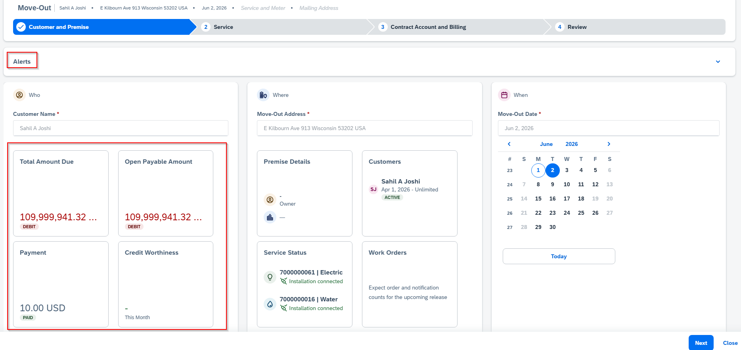
Figure 5a — SC V2 reference screen: Move-Out Service tab with determination mashup
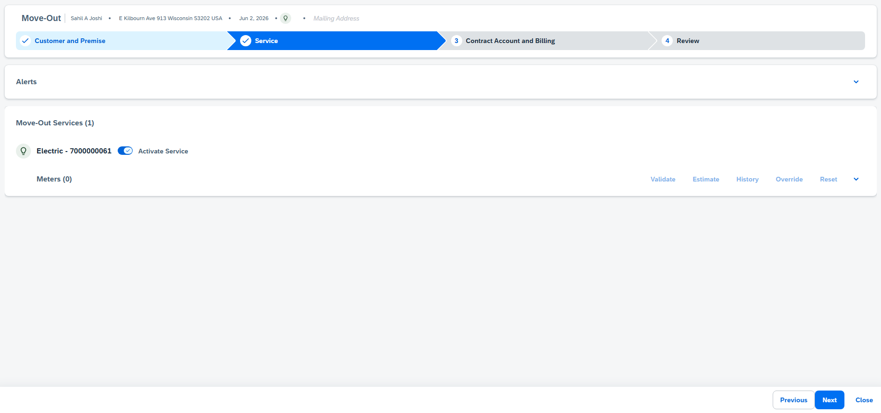
Figure 5b — SC V2 reference screen: rule chain and resulting proposal
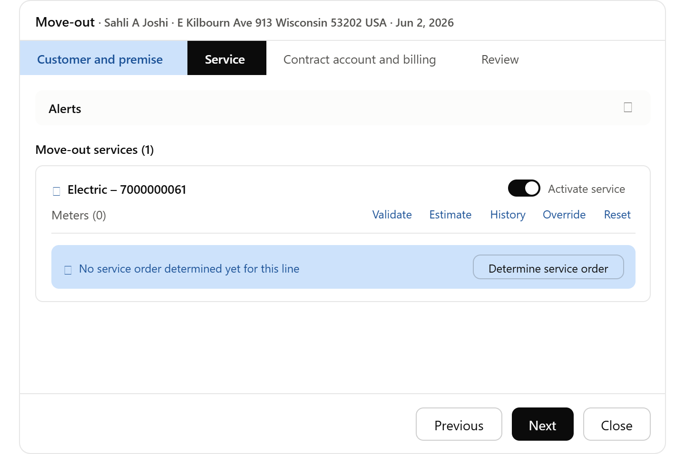
Figure 5c — SC V2 reference screen: proposal accepted, service order created
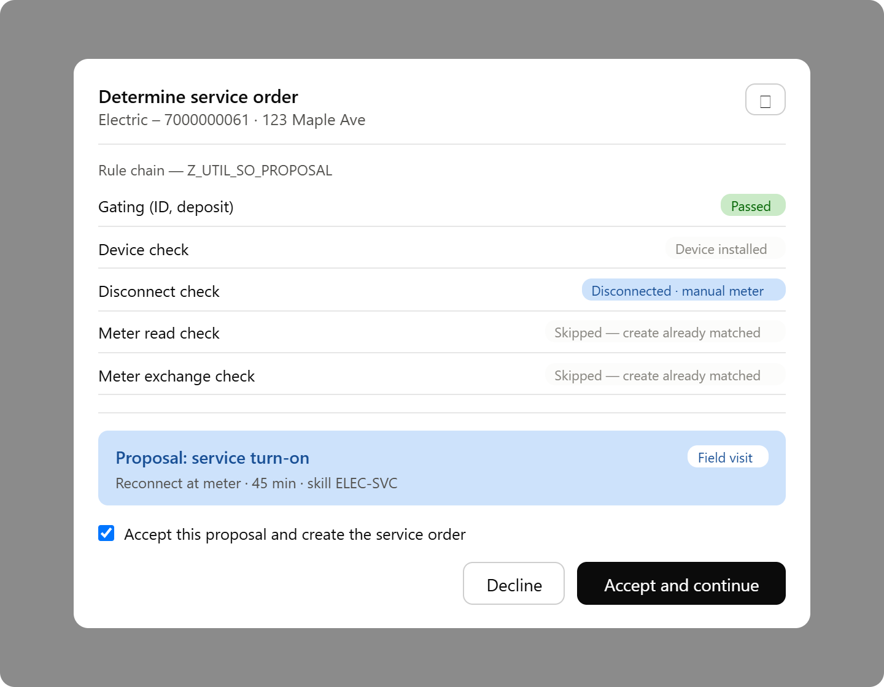
Figure 5d — SC V2 reference screen: determination result detail

Figure 5e — SC V2 reference screen: additional determination view

5.11 Service Order Determination BRF+ Technical Design
BRF+ application Z_CS_MOVE_SO_DET implements the rule chain above as four decision functions sharing one result structure. Online functions are invoked by the move-in/move-out enhancements; batch functions are invoked by the daily RSS program. Exactly one result flag returns TRUE per evaluation, and rules are evaluated top-down — the first matching row wins ('*' = any value).

Functions and Result Structure
Function | Trigger | Output
FN_MOVE_IN_VALIDATION | Move-in / transfer-in creation, per installation | OPT_IN_SO, OPT_OUT_SO, DISC_RECN, EXIT (exactly one TRUE)
FN_MOVE_OUT_VALIDATION | Move-out / transfer-out creation, per installation | OPT_IN_SO, OPT_OUT_SO, MTR_REMOVAL, DISC_RECN, EXIT
FN_BATCH_MOVE_OUT | Daily batch (01:00–05:00), runs first, per move-out document due | RSS (Boolean), MESSAGE (application-log text)
FN_BATCH_MOVE_IN | Daily batch, runs after move-out mode, per move-in document due | RSS (Boolean), MESSAGE

Key Condition Derivations
Condition | Derivation | Source
DIV_99 | Installation division = '99' (Added Facility) no turn-on/off ever | EANL / installation attributes
BILLING_BLOCK | EVER-ABRSPERR set on the move-in contract; agent creates order manually after removal | EVER
OPT_OUT_REQ | Customer requested AMI opt-out during move-in (custom attribute) | Move-in payload
MTR_REM_REQ | Customer requested turn-off with meter removal | Move-out payload
AMI_METER | Installed device is AMI with remote disconnect/reconnect (RSS) capability | EASTL, EGERH
OPEN_TOFF_OPTIN | Open Turn-Off Opt-In order exists (type TOFF, status 10/20, ILART 233) | AFIH
NEXT_DAY_MOVE_IN | Move-in exists dated move-out date + 1 for the same installation | EVER
DISC_STATUS | ISU_INSTLN_STATUS_DETERMINE: 05/10 = disconnected; 00/15 = energized | Disconnection document status
OPEN_FIELD_SO | Open turn-on/off/replacement/removal order already exists | PM orders

Decision Table DT_MOVE_IN (online)
R# | DIV_99 | BILLING_BLOCK | AMI_METER | OPEN_TOFF_OPTIN | Result | Action
1 | Y | * | * | * | EXIT | No order (Added Facility)
2 | N | Y | * | * | EXIT | No order; agent creates manually after block removal
3 | N | N | * | * | DISC_RECN | Activity=Move-In; mechanical only → Turn-On if disconnected
4 | N | N | * | Y | EXIT | Cancel in-flight Turn-Off Opt-In, suppress new opt-out order
5 | N | N | Y | N | OPT_OUT_SO | Turn-On Opt-Out exchange (Z237): AMI → mechanical
6 | N | N | Y | * | DISC_RECN | Same-day RSS reconnect / future-dated batch / declined → Turn-On field order
7 | N | N | N | Y | EXIT | In-flight Turn-Off Opt-In installs AMI; no second order
8 | N | N | N | N | OPT_IN_SO | Turn-On Opt-In exchange (Z236): mechanical → AMI
Full condition set includes CATALINA and OPT_OUT_REQ columns omitted above for width; see Section 5.9 condition derivations for the complete rule logic per row.

Decision Table DT_MOVE_OUT (online)
R# | DIV_99 | MTR_REM_REQ | NEXT_DAY_MOVE_IN | AMI_METER | Result | Action
1 | Y | * | * | * | EXIT | No order (Added Facility)
2 | N | Y | * | * | MTR_REMOVAL | Meter Removal order (Z214); turn-off accompanies via D&F rules
3 | N | N | * | * | DISC_RECN | Activity=Move-Out; Turn-Off field order
4 | N | N | Y | * | EXIT | Back-to-back occupancy: no disconnection
5 | N | N | N | N | OPT_IN_SO | Turn-Off Opt-In exchange (Z233): mechanical → AMI on exit
6 | N | N | N | Y | DISC_RECN | Same-day RSS disconnect / future-dated batch

Daily Batch Tables (RSS reconnect/disconnect)
Seq | Check (stop at first hit) | If TRUE | If FALSE
0 | Move document reversed | Skip document | Continue
1 | NEXT_DAY_MOVE_IN exists (batch move-out only) | RSS=FALSE; log 'Next Day Move-In' | Continue
2 | OWNER_ALLOC active (batch move-out only) | RSS=FALSE; log 'Owner Allocation' | Continue
3 | OPEN_FIELD_SO exists | RSS=FALSE; log 'Open Service Orders' | Continue
4 | DISC_STATUS already in target state | RSS=FALSE; log accordingly | Continue
5 | All checks passed | RSS=TRUE → D&F rules (1467) issues the RSS command | —

Service Order Codes
Code | Order | Trigger | Reference Object
Z214 | Meter Removal | Move-out with CREATE_SERVICE='X' | Equipment
Z233 | Turn-Off Opt-In exchange | Move-out of an opt-out customer | Equipment — exchanges mechanical→AMI on exit
Z236 | Turn-On Opt-In exchange | Move-in where prior customer was opt-out | Premise — exchanges mechanical→AMI
Z237 | Turn-On Opt-Out exchange | Move-in where customer opts out of AMI | Equipment — exchanges AMI→mechanical
TUON / TOFF | Standard Turn-On/Turn-Off | DISC_RECN | Installation/device location
- Creation FM (C4C-era): ISU_C4C_SRV_ORD_CREATE with IV_ACTIONCODE '01' (create) / '03' (cancel); start date = requested move date, or system date if backdated
- Device-location resolution: installation → EASTL → EGERH; de-duplicated so exactly one order is created per device location — a premise with electric, gas and water yields one order per commodity.

6. End-to-End Scenarios

6.1 Move-In requiring Turn-On (field)
- CSR starts Move-In: premise shows Electric + Water installations; customer, address, move-in date captured.
- Service step: Z_UTIL_SO_PROPOSAL → Electric disconnected/manual → Turn-On (FIELD, 45 min, ELEC-SVC); Water connected/AMI → remote Move-In read (REMOTE).
- Appointment panel (Electric only): slot search to FSM → CSR books Tue 12:00–16:00; reservation held.
- Contract Account/Billing and Review steps; CSR submits.
- SC V2 posts move-in to S/4HANA and creates the service order (Turn-On) with booking ID; water remote-read command queued via AMI.
- S/4HANA order → FSM activity pinned to the booked window; dispatcher releases; internal technician executes in SSAM: reconnects, enters start read, device status updated.
- Completion → order TECO, move-in billing-ready; SC V2 order closes; case timeline updated; customer notified.

6.2 Move-Out with Remote Disconnect (AMI)
- Service step: Electric AMI with switch, no successor → remote Turn-Off + final read (REMOTE). No appointment UI shown.
- CSR submits; S/4HANA posts move-out, triggers AMI disconnect + on-demand final read at the move-out date; no FSM/SSAM involvement.
- Command result confirms; final bill produced; SC V2 case auto-completes with the execution log.
- Fallback: command failure after N retries auto-converts the order to FIELD, books via FSM, and alerts the case owner.

6.3 Transfer
- One SC V2 transfer flow = Move-Out + Move-In in a single case; determination and, where needed, slot booking run per premise.
- Consolidated review shows both premises' proposals and appointments before one submit; two S/4 documents + orders are created, cross-referenced to the case.

6.4 Standalone Service Order
- CSR opens Service Orders → Create Service Order; selects account, premise and Service Order Type (e.g. Meter Exchange).
- Order type resolves duration + skill; 'Find Appointment' runs the FSM slot search; chosen slot fills Requested Start/End; booking reserved.
- Save & Open → order replicates to S/4HANA and on to FSM against the booked window; execution and completion as in 6.1.

7. Object and Status Mapping

7.1 Object Mapping
SC V2 | S/4HANA Utilities / Service | FSM | SSAM
Case (Move-In/Move-Out/Transfer) | Move-in/move-out document(s) | — | —
Service Order (+ type, requested start/end, booking ID) | Service/IS-U work order (+ operation dates, device, functional location) | Service Call + Activity (+ booking/planned assignment) | Work Order in technician queue
Registered product / premise reference | Premise, PoD, installation, device (equipment) | Equipment / address (geo) | Equipment + device data incl. meter
Appointment panel fields (adult present, meet-me phone, note) | Order header/operation texts + extension fields | Activity remarks / custom fields | Visible in order details
Timeline entries | Order status/action log | Booking + assignment history | Mobile status trace

7.2 Status Mapping
SC V2 Service Order | S/4HANA order | FSM | Trigger
Open | Created (CRTD) | — (booking may already exist) | CSR saves order / wizard submit
Released / In Process | Released (REL) | Service call Ready → Dispatched; activity assigned in booked window | Replication + dispatcher release
In Execution | In process (partial confirmations) | Activity En Route / Working | Technician status updates
Completed | Finally confirmed / TECO | Activity Closed / checkout done | Completion posting incl. device & read data
Cancelled | Cancelled / locked | Booking cancelled (de-appointment) | Cancellation event, reason mandatory

8. Interface Inventory
ID | Name | Source → Target | Package / Mechanism | Mode
IF-01 | Appointment slot search | SC V2 → FSM (Booking API search-slots) | Custom side-by-side service | Sync REST
IF-02 | Slot reserve / book / cancel | SC V2 → FSM (Booking API) | Custom side-by-side service | Sync REST
IF-03 | Service order eligibility & proposal | SC V2 → S/4HANA (Z_UTIL_SO_PROPOSAL) | Custom OData action | Sync
IF-04 | Move-in / move-out posting; premise replication | SC V2 ↔ S/4HANA Utilities | SC V2 for Utilities Premise Integration with S/4HANA | Async
IF-05 | Service order replication & status | SC V2 ↔ S/4HANA Service | Prepackaged integration, Event Mesh | Async events
IF-06 | Order → field execution | S/4HANA ↔ FSM | SAP S/4HANA Integration with SAP FSM: Replicate Service Order (SOAP); Notify/Update Service Order Update | Async
IF-07 | Mobile execution (internal crews) | S/4HANA ↔ SSAM | SAP Mobile Services; Meter Management add-on | Sync/offline
IF-08 | Remote meter commands | S/4HANA → AMI head-end / MDM | Existing AMI integration (MDUS) | Async command + confirmation
IF-09 | Master data alignment | S/4HANA → FSM (BP, equipment, skills); S/4HANA ↔ SC V2 (BP, premise, registered products) | Value Mapping for Master Data; Replicate Utilities Premise Connection Object | Async delta
iFlow names for IF-06 and IF-09 are sourced from the prepackaged SAP Business Accelerator Hub content ("SAP S/4HANA Integration with SAP Field Service Management" and "SAP Service Cloud V2 for Utilities Premise Integration with SAP S/4HANA" packages). IF-01/IF-02 (FSM Booking API) and IF-03 (Z_UTIL_SO_PROPOSAL) are not prepackaged content — they are custom, as noted in Section 3.3, D3.

9. Non-Functional Design

9.1 Security
- All API calls use OAuth 2.0 client-credential or SAML-bearer flows via BTP destinations; no credentials in SC V2 front-end code.
- FSM Booking calls scoped to the FSM account/company; S/4 OData exposed through a dedicated communication arrangement with least-privilege authorizations.
- CSR authorization: appointment booking and proposal override rights controlled by SC V2 business roles (parity with legacy business-role gating).
- Auditability: every proposal acceptance/decline, booking, rebooking and cancellation is written to the case timeline with user and timestamp.

9.2 Performance Targets
Interaction | Target
Eligibility & proposal call (IF-03) | ≤ 2s p95 (single round trip; rules co-located with data)
Slot search (IF-01) | ≤ 3s p95 for a 10-day horizon
Slot reserve/confirm (IF-02) | ≤ 1.5s p95
Order replication to FSM-visible activity | ≤ 2 min p95 (async)
Status round trip technician → SC V2 | ≤ 2 min p95

9.3 Resilience and Operations
- Graceful degradation defined for every sync call (Section 4.6); no CSR flow is ever hard-blocked by FSM availability.
- Idempotent order/booking correlation via external reference IDs to survive retries without duplicates.
- End-to-end monitoring in SAP Cloud ALM: iFlow failures, booking-orphan detection job, command-failure alerts for AMI.
- Time zones: slots searched/displayed in the premise's local time zone; persisted timestamps in UTC; DST transitions covered by test cases.

10. Assumptions and Open Points

10.1 Assumptions
- SC V2 Utilities extension (Move-In/Move-Out guided flows) is licensed and activated, with S/4HANA Utilities prepackaged integration content.
- FSM is the single scheduling engine for field work in scope; existing IS-U appointment-book usage is retired for these processes.
- S/4HANA Service (or IS-U work management orders) is active so orders can flow to both FSM and SSAM from one backbone.
- AMI head-end integration for remote disconnect/reconnect/read already exists in S/4HANA and is reusable as a service.
- Skill and duration catalogs per service order type will be provided by field operations during realization.

10.2 Open Points
# | Open point | Owner | Needed by

11. Glossary
Term | Definition
AMI / AMR | Advanced Metering Infrastructure (two-way, remote-command capable) / Automated Meter Reading (one-way)
Booking API | FSM REST API returning bookable appointment slots and managing reservations/bookings
BRFplus | SAP business rules framework used for the eligibility decision tables in S/4HANA
CM_ENH_350 | Legacy CRM 7.0 enhancement 'Contract Mgt New Contract Notification' — functional reference for this design
FSM | SAP Field Service Management — scheduling, dispatch and contractor mobile
IS-U | Industry solution Utilities within S/4HANA (device management, move-in/out, billing)
RSS | Remote Switch Service — AMI-based remote connect/disconnect command
SC V2 | SAP Sales and Service Cloud Version 2
SSAM | SAP Service and Asset Manager — mobile execution app for S/4HANA work orders (internal crews)
TECO | Technically complete (S/4HANA order status)
TTL | Time-to-live of a slot reservation before it is auto-released

